Adventure XLVIII -- The Valley of Fear

SUMMARY (Diogenes Club)
Watson is living at Baker St.
Porlock sends Holmes a letter saying that Douglas is in danger at Birlstone. Within minutes, MacDonald comes to consult Holmes on the very issue.
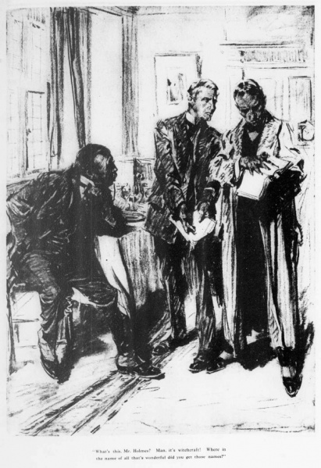
Holmes discourses at length about the evil of Moriarity and the extent of his empire.
The Douglases are living a quiet retired life at Birlstone. Mr. Douglas is an American and has told his wife nothing of his life prior to their marriage.
He is murdered in his study by a double-barreled shotgun blast in the face. His wedding ring has been taken but nothing else indicates robbery as a motive. Mr. Douglas has an old brand on his forearm – a triangle within a circle.
Douglas worked out regularly and one of his dumb bells is missing. This is a big clue in Holmes’ mind.
Earlier in his life Douglas was a Pinkerton agent. He had become a Scowrer in Pennsylvania. The Scowerers were members of a lodge whose purpose was to terrorize and extort miners and mine owners. Part of his initiation into the lodge was to be branded. He betrayed the group to Pinkerton and they vowed to kill him.
The Scowrers traced Douglas to England and sent Baldwin to kill him. In a fight between Douglas and Baldwin, they wrestled with the shot-gun which discharged both barrels into Baldwin’s face. Douglas and Barker seized the opportunity to exchange identities and make the Scowrers think that Douglas was finally dead so they would stop hounding him.

After his flight to England, the Scowerers employed Moriarity’s agency to find Douglas there.
Holmes sees through the switch of identities. Douglas is acquitted on self defense. He and his wife go to South Africa to start life anew. Douglas is lost at sea. Holmes is sure Moriarity had him drowned and vows to stop the "Napoleon of crime."

SUMMARY (Wikipedia)
Sherlock Holmes receives a cipher message from Fred Porlock, a pseudonymous agent of Professor Moriarty. After Porlock sends the message, however, he changes his mind for fear of Moriarty's discovering that he is a traitor. He decides not to send the key to the cipher, but he sends Holmes a note telling of this decision. From the cipher message and the second note, Holmes is able to deduce that it is a book cipher and that the book used for the encryption is a common book, large (with at least 534 pages), printed in two columns per page, and standardised. An almanac fits these conditions exactly.
Holmes tries the latest edition of Whitaker's Almanac, which he had only received a few days earlier, and fails; he then tries the previous edition. With this almanac, Holmes is able to decipher the message as a warning of a nefarious plot against one Douglas, a country gentleman residing at Birlstone House. Some minutes later, Inspector MacDonald arrives at 221B Baker Street with news that a Mr. John Douglas of Birlstone Manor House, Birlstone, Sussex, has been murdered. Holmes tells MacDonald of Porlock's warning, suggesting Moriarty's involvement. However, MacDonald does not fully believe that the educated and well-respected Moriarty is a criminal. Holmes, Watson, and MacDonald travel to Birlstone House, an ancient moated manor house, to investigate the crime.
Douglas had been murdered the evening before. Cecil Barker, a frequent guest at Birlstone House, had been in his room at half-past eleven when he heard the report of a gun, according to his testimony. He had rushed down to find Douglas lying in the centre of the room nearest the front door of the house, a sawn-off shotgun lying across his chest. He had been shot at close range: receiving the full charge of the shotgun in the face, his head was blown 'almost to pieces'. Barker had rushed to the village police station and notified Sergeant Wilson, who was in charge of the station. Wilson followed Barker to the house after notifying the county authorities.
Wilson had begun investigating immediately. Barker drew his attention to the open window, and to a smudge of blood like the mark of a boot-sole upon the window sill. The drawbridge over the moat had been raised at 6:00 pm. Barker speculated that the murderer had entered by the drawbridge before that time, hid in the room, and left by the window directly after killing Douglas. The moat was only a few feet deep, and could be easily crossed. Wilson found a card beside the corpse with the initials "V.V." and the number 341 beneath them. Muddy boot-prints were found behind the curtains, bearing out Barker's theory. On the murdered man's forearm was a curious design, a triangle within a circle; it was not a tattoo, but a brand. This mark had been noticed many times before upon John Douglas's forearm. Douglas' wedding ring appeared to have been taken from his hand. The chief Sussex detective, White Mason, had arrived at Birlstone House by 3:00 in the morning. By 5:45, he had sent for Scotland Yard. MacDonald took the case, and notified Holmes because he thought Holmes would be interested. By noon, MacDonald, Holmes and Watson meet White Mason in Birlstone.
Holmes, MacDonald, and White Mason go to the scene of the murder. They discuss the case, agreeing that suicide is out of the question, and that someone from outside the house committed the murder. Barker believes a secret society of men pursued Douglas, and that he retreated to rural England out of fear for his life. Douglas married after arriving in England five years earlier. His first wife had died of typhoid. He had met and worked with Barker in America before departing for Europe. Some episode of Douglas's life in America caused the fear for his life, and Mrs. Douglas said her husband mentioned something called "The Valley of Fear".
By studying Barker's slippers, Holmes determines Barker's shoe made the mark on the window, to give the appearance that someone exited that way. In their lodgings, Holmes tells Watson that Barker and Mrs. Douglas are certainly lying: the events as they tell them would be impossible. Moreover, Holmes learns that the housekeeper heard a sound, as if of a door slamming, half an hour before the alarm; Holmes believes that this sound was the fatal shot. White Mason and MacDonald track a bicycle found on the grounds of the house to an American staying at a guest house. The American appears to be the murderer, but there is no sign of the man.
Holmes asks MacDonald to write to Barker, telling him that the police intend to search the moat the next day. That night Holmes, Watson, MacDonald and White Mason lie in wait outside Birlstone Manor and see Barker fish something out of the moat. The four men rush Barker and discover the bundle from the moat contains the clothes of the missing American connected with the bicycle. Barker refuses to explain the situation. At that moment, Douglas appears, alive and well. He hands Watson a written account called "The Valley of Fear", which explains why he feared for his life.
Douglas explains that he had spotted an enemy of his, Ted Baldwin, in the area and expected an attack. When Baldwin attempted to shoot Douglas in his study, Douglas grabbed the gun and, in the struggle, Baldwin was shot in the face. With Barker's help, Douglas dressed the man in his own clothes, except for Douglas's wedding ring, to deceive the secret society which he and Baldwin had belonged to, since both arms bore the society's mark. Barker and Mrs. Douglas had covered for Douglas, who had been hiding in a secret compartment in the room where the shooting occurred. In an interview with Watson, Douglas explains that his real name was Birdy Edwards and he had been a Pinkerton detective in Chicago. Edwards had infiltrated a murderous gang, known by locals as the Scowrers, in Vermissa Valley (a.k.a. the Valley of Fear) and brought them to justice. Afterwards, the criminals attempted to kill him after being released from jail.
Hounded, Douglas had run to England, where he met and married his second wife. Holmes urges Douglas to leave England and warns that a new threat now hangs over him. Douglas takes this advice, but, shortly after, Holmes learns from Barker that Douglas was lost overboard on the vessel to Africa. Holmes believes Moriarty was responsible for ending Douglas' life. Holmes wants to bring Moriarty down, but warns Watson and Barker that it will take some time to achieve.

